**[SECURE THE CHILD'S FUTURE](https://securethechildsfuture.org/)**

[**HOME**](https://securethechildsfuture.org/)

**ABOUT**

[**OUR MISSION**](https://securethechildsfuture.org/our-mission/)

[**WHO WE ARE**](https://securethechildsfuture.org/who-we-are/)

[**SCHOOLS**](https://securethechildsfuture.org/schools/)

[**COMING SOON!**](https://securethechildsfuture.org/coming-soon/)

[**CONTACT**](https://securethechildsfuture.org/contact-1/)

[**BLOG**](https://securethechildsfuture.org/news/)

[**TAKE ACTION**](https://securethechildsfuture.org/take-action/)

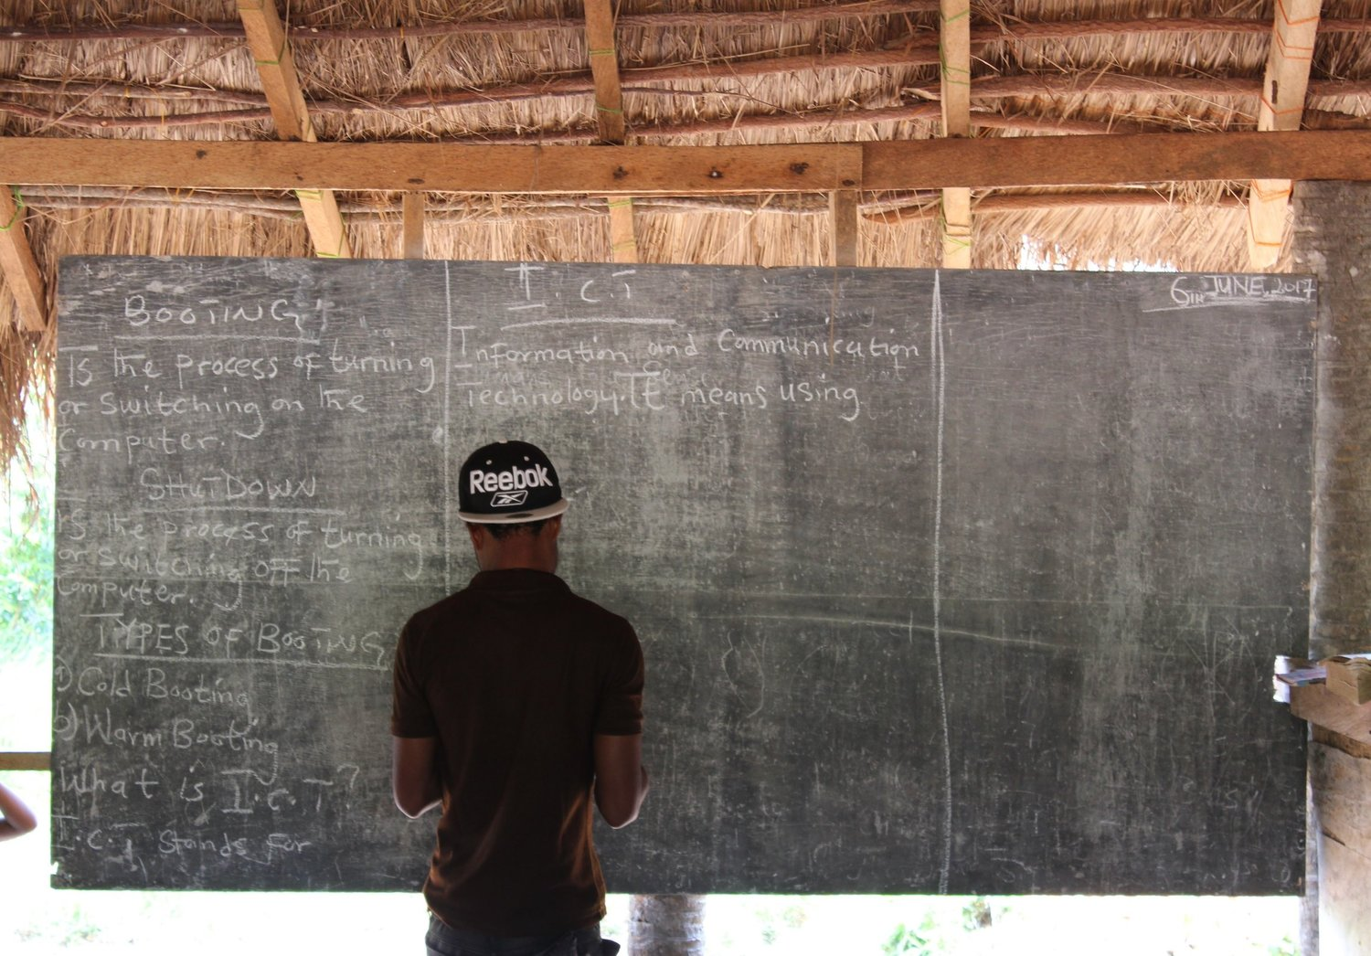

*Education*

**STARTS WITH YOU**

[**LEARN MORE**](https://securethechildsfuture.org/our-mission)

Providing ICT Education in Rural Ghana

In western society most children are taught how to use computers and mobile devices from a young age. In rural Ghana most children won't even have access to a computer or mobile computer. If these students progress to high school and the university they are far behind their peers. Those who don't make it to high school are ill prepared for their future in their quickly modernizing world. We are fixing this by providing quality education for rural students in information and communication technology. We are working on building e-learning centers for two villages in Ghana. These e-learning centers will give students access and education in using computers, mobile devices, and the internet. Find out how your can help us.

[[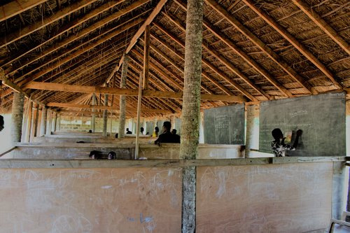](https://securethechildsfuture.org/our-mission)](https://securethechildsfuture.org/our-mission)

[OUR VISION](https://securethechildsfuture.org/our-mission)

Find out about our vision, the schools in need, and our plans for the future.

[Learn More →](https://securethechildsfuture.org/our-mission)

[[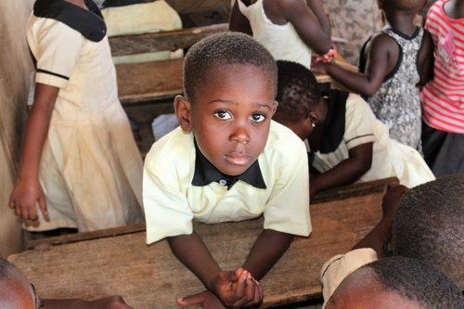](https://securethechildsfuture.org/take-action)](https://securethechildsfuture.org/take-action)

[TAKE ACTION](https://securethechildsfuture.org/take-action)

We need your help! You can help us provide an education for students in need.

[Find Out How →](https://securethechildsfuture.org/take-action)

Powered by [Squarespace](http://www.squarespace.com/?channel=word_of_mouth&subchannel=customer&source=footer&campaign=4fd1028ee4b02be53c65dfb3)

[**SECURE THE CHILD'S FUTURE**](https://securethechildsfuture.org/)

[**HOME**](https://securethechildsfuture.org/)

**ABOUT**

[**OUR MISSION**](https://securethechildsfuture.org/our-mission/)

[**WHO WE ARE**](https://securethechildsfuture.org/who-we-are/)

[**SCHOOLS**](https://securethechildsfuture.org/schools/)

[**COMING SOON!**](https://securethechildsfuture.org/coming-soon/)

[**CONTACT**](https://securethechildsfuture.org/contact-1/)

[**BLOG**](https://securethechildsfuture.org/news/)

[**TAKE ACTION**](https://securethechildsfuture.org/take-action/)

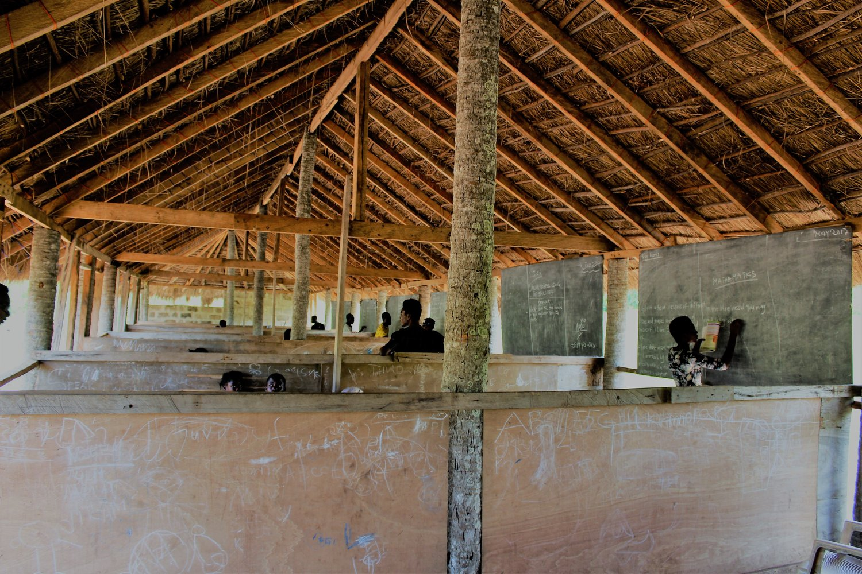

**OUR MISSION**

* About
* [**OUR MISSION**](https://securethechildsfuture.org/our-mission/)
* [**WHO WE ARE**](https://securethechildsfuture.org/who-we-are/)
* [**SCHOOLS**](https://securethechildsfuture.org/schools/)
* [**COMING SOON!**](https://securethechildsfuture.org/coming-soon/)
* [**CONTACT**](https://securethechildsfuture.org/contact-1/)

Education is the key to providing a successful future for children all around the world. As the world becomes more interconnected, a strong education in information technology for children in the developing world is more important than ever.

OUR MISSION

We are aiming to build e-learning centers for schools all around Ghana. Public schools in rural Ghana receive far too little funding to provide this education and quality private schools are expensive and hard to find. Most schools provide ICT education but it is incredibly limited and provides no opportunity for the students to apply their knowledge. This is what a typical rural education in ICT looks like.

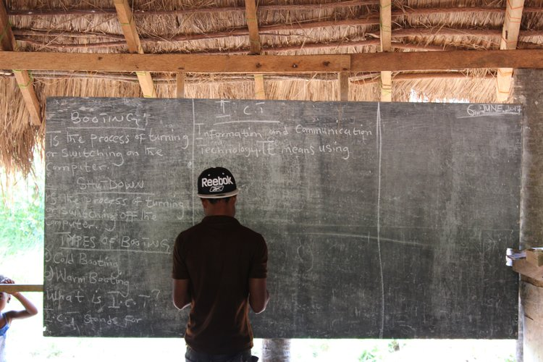

E-LEARNING CENTERS

Instead of simply providing theoretical learning, these students need hands on experiences and practical applications. Our E-learning centers will provide these hands on experiences. Each E-learning center will come equipped with several microcomputers such as the Raspberry Pi with monitors, keyboards, and mice. Children will learn basic computer skills such as how to type with a keyboard and mouse, create, move and delete files, use modern word processors, and safely browse the web.

“Education is the passport to the future, for tomorrow belongs to those who prepare for it today.

— Malcolm X

Powered by [Squarespace](http://www.squarespace.com/?channel=word_of_mouth&subchannel=customer&source=footer&campaign=4fd1028ee4b02be53c65dfb3)

[**SECURE THE CHILD'S FUTURE**](https://securethechildsfuture.org/)

[**HOME**](https://securethechildsfuture.org/)

**ABOUT**

[**OUR MISSION**](https://securethechildsfuture.org/our-mission/)

[**WHO WE ARE**](https://securethechildsfuture.org/who-we-are/)

[**SCHOOLS**](https://securethechildsfuture.org/schools/)

[**COMING SOON!**](https://securethechildsfuture.org/coming-soon/)

[**CONTACT**](https://securethechildsfuture.org/contact-1/)

[**BLOG**](https://securethechildsfuture.org/news/)

[**TAKE ACTION**](https://securethechildsfuture.org/take-action/)

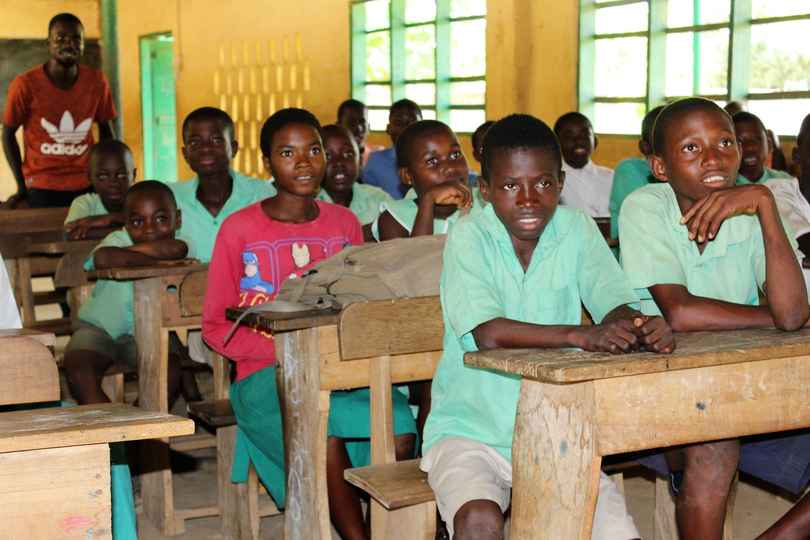

**SCHOOLS**

* About
* [**OUR MISSION**](https://securethechildsfuture.org/our-mission/)
* [**WHO WE ARE**](https://securethechildsfuture.org/who-we-are/)
* [**SCHOOLS**](https://securethechildsfuture.org/schools/)
* [**COMING SOON!**](https://securethechildsfuture.org/coming-soon/)
* [**CONTACT**](https://securethechildsfuture.org/contact-1/)

Here are the two schools we are supporting currently.

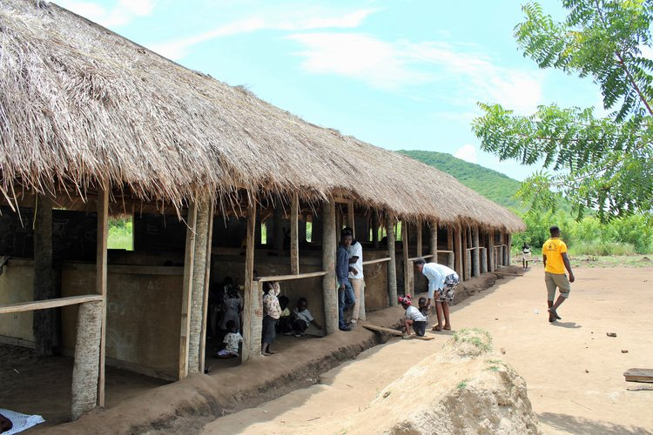

MANKWADZE, CENTRAL REGION

Mankwadze is a small fishing village on the coast of Ghana. This school, School Name, contains 6 classrooms for each grade from pre-school up to 5th grade. The classrooms each contain a chalkboard and barely enough chairs for each student. The thatch roof helps protect the students from the blistering sun but doesn't stop water from coming into the classrooms when the rain comes.

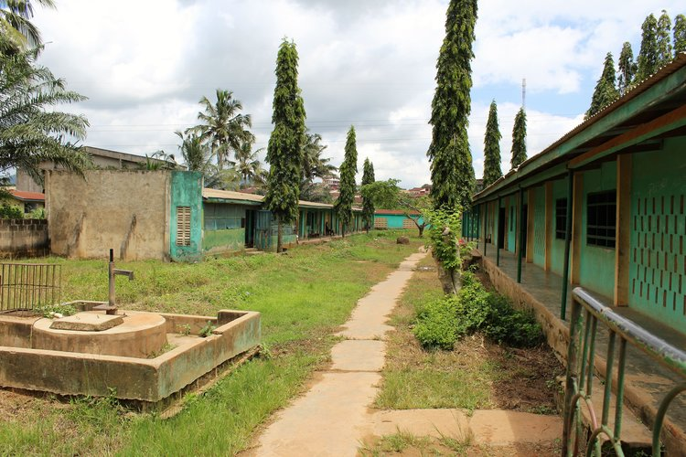

NKAWKAW, EASTERN REGION

Nkawkaw is a village in Eastern Region near the central part of the country. This school, School Name, is made up of students from Grade # to Grade #. It consists of three main buildings for classrooms, administration, and dormitories and a central well for water.

Powered by [Squarespace](http://www.squarespace.com/?channel=word_of_mouth&subchannel=customer&source=footer&campaign=4fd1028ee4b02be53c65dfb3)

# [SECURE THE CHILD'S FUTURE](https://securethechildsfuture.org/)

[**HOME**](https://securethechildsfuture.org/)

**ABOUT**

[**OUR MISSION**](https://securethechildsfuture.org/our-mission/)

[**WHO WE ARE**](https://securethechildsfuture.org/who-we-are/)

[**SCHOOLS**](https://securethechildsfuture.org/schools/)

[**COMING SOON!**](https://securethechildsfuture.org/coming-soon/)

[**CONTACT**](https://securethechildsfuture.org/contact-1/)

[**BLOG**](https://securethechildsfuture.org/news/)

[**TAKE ACTION**](https://securethechildsfuture.org/take-action/)

* About
* [**OUR MISSION**](https://securethechildsfuture.org/our-mission/)
* [**WHO WE ARE**](https://securethechildsfuture.org/who-we-are/)
* [**SCHOOLS**](https://securethechildsfuture.org/schools/)
* [**COMING SOON!**](https://securethechildsfuture.org/coming-soon/)
* [**CONTACT**](https://securethechildsfuture.org/contact-1/)

### CHECK BACK LATER FOR OTHER OPPORTUNITIES TO HELP!

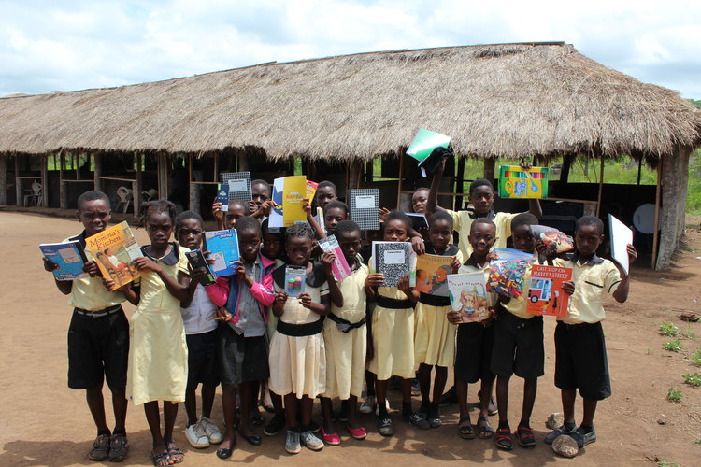

### SPONSOR A STUDENT

Soon we will be starting our sponsorship program to allow you to directly sponsor a student. Your sponsorship will provide school fees for a student and allow you to make a direct impact on a child's life.

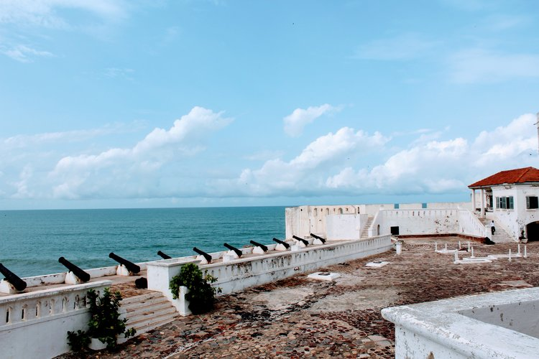

### VOLUNTEER IN GHANA

We are also hoping to start our volunteer program for students to come to Ghana and teach in these schools. The program will include cultural activities and tours to popular tourist attractions.

Powered by [Squarespace](http://www.squarespace.com/?channel=word_of_mouth&subchannel=customer&source=footer&campaign=4fd1028ee4b02be53c65dfb3)

# [SECURE THE CHILD'S FUTURE](https://securethechildsfuture.org/)

[**HOME**](https://securethechildsfuture.org/)

**ABOUT**

[**OUR MISSION**](https://securethechildsfuture.org/our-mission/)

[**WHO WE ARE**](https://securethechildsfuture.org/who-we-are/)

[**SCHOOLS**](https://securethechildsfuture.org/schools/)

[**COMING SOON!**](https://securethechildsfuture.org/coming-soon/)

[**CONTACT**](https://securethechildsfuture.org/contact-1/)

[**BLOG**](https://securethechildsfuture.org/news/)

[**TAKE ACTION**](https://securethechildsfuture.org/take-action/)

* About
* [**OUR MISSION**](https://securethechildsfuture.org/our-mission/)
* [**WHO WE ARE**](https://securethechildsfuture.org/who-we-are/)
* [**SCHOOLS**](https://securethechildsfuture.org/schools/)
* [**COMING SOON!**](https://securethechildsfuture.org/coming-soon/)
* [**CONTACT**](https://securethechildsfuture.org/contact-1/)

# Contact Us

Thank you for visiting our site! If you haven't already please visit our fundraising site [here](https://www.youcaring.com/securethechildsfuture-906511). We greatly appreciate your generosity in helping provide a better future for these children. If you have additional questions or wish to donate supplies directly please fill out this form to get in touch with us.

### PLEASE COMPLETE THE FORM BELOW

Top of Form

Name *

First Name

Last Name

Email Address *

Subject *

Message *

Bottom of Form

Powered by [Squarespace](http://www.squarespace.com/?channel=word_of_mouth&subchannel=customer&source=footer&campaign=4fd1028ee4b02be53c65dfb3)

[**SECURE THE CHILD'S FUTURE**](https://securethechildsfuture.org/)

[**HOME**](https://securethechildsfuture.org/)

**ABOUT**

[**OUR MISSION**](https://securethechildsfuture.org/our-mission/)

[**WHO WE ARE**](https://securethechildsfuture.org/who-we-are/)

[**SCHOOLS**](https://securethechildsfuture.org/schools/)

[**COMING SOON!**](https://securethechildsfuture.org/coming-soon/)

[**CONTACT**](https://securethechildsfuture.org/contact-1/)

[**BLOG**](https://securethechildsfuture.org/news/)

[**TAKE ACTION**](https://securethechildsfuture.org/take-action/)

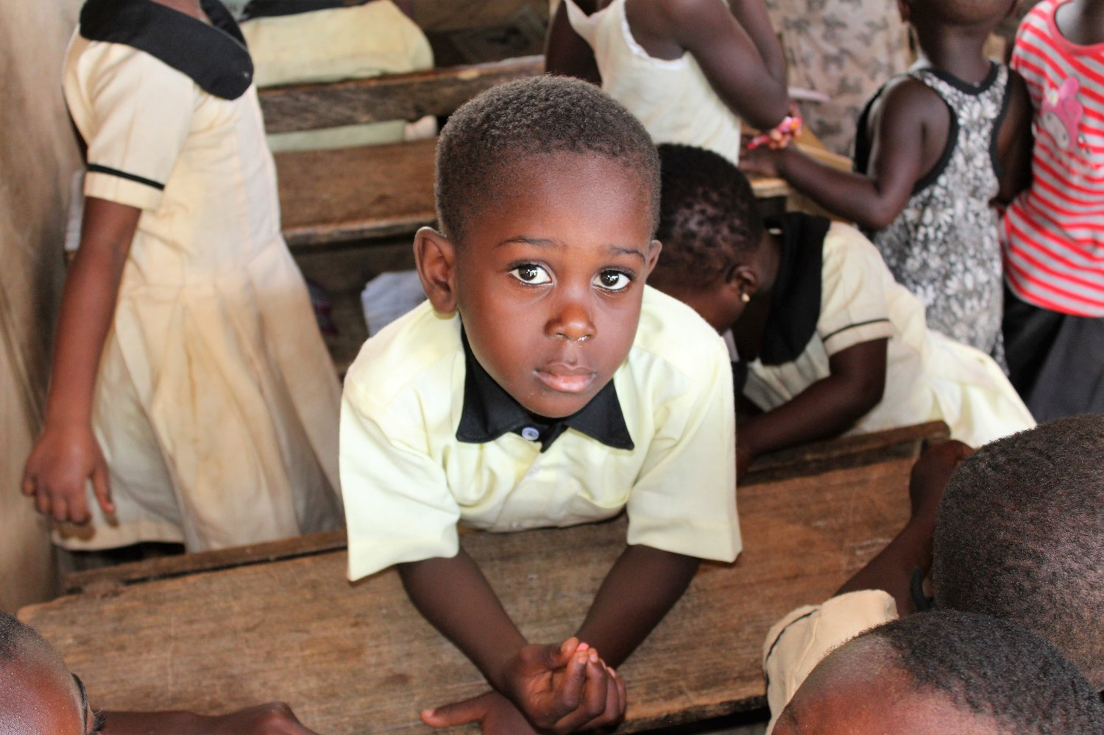

**TAKE ACTION**

Your help will make a difference. Your donations will go directly to building E-learning centers in schools in rural Ghana. These E-learning centers will provide students with the skills they need to succeed in a modernizing world. Please follow either of the following links to help our cause.

DONATE MONEY

Your monetary donation will allow us to build and provide electricity for these e-learning centers in Ghana. It will also assist us in purchasing affordable equipment such as Raspberry Pi computers, monitors, keyboards, and mice.

[Make a Donation →](https://www.youcaring.com/securethechildsfuture-906511)

DONATE MATERIALS

We are also accepting materials and equipment to donate directly to these schools. We are in need of standard school supplies, keyboards, mice, used mobile devices, or Raspberry Pi's. Please follow the link below to get in contact with us.

[Contact Us →](https://securethechildsfuture.org/contact-1)

Powered by [Squarespace](http://www.squarespace.com/?channel=word_of_mouth&subchannel=customer&source=footer&campaign=4fd1028ee4b02be53c65dfb3)

**STARTS WITH YOU**